**BRRRRRR!!!**

In Science class, Mr. Smith did a demonstration and a discussion.

Heat Donation

In this demonstration, Mr. Smith put menthol alcohol on our wrists, and then had us blow on them. It was extremely cold, because menthol alcohol is very volatile, which means it evaporates very quickly. Because of this, you lose heat very fast when it evaporates.

State Change Chart

In this discussion, Mr. Smith taught us how this chart works:

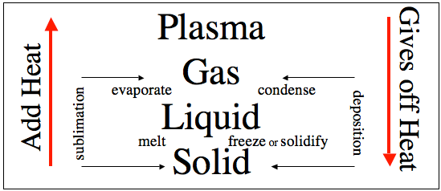

The process of going from a solid to liquid is called melting, and it involves adding heat. The process of going from a liquid to a gas is called evaporating, and it involves adding heat. The process of going from a gas to plasma doesn’t have a name, but basically it is superheating the gas, and it involves adding heat. The process of going straight from a solid to a gas is called sublimation, and it involves adding heat. An example of something that does this is dry ice. The process of going from a plasma to a gas doesn’t have a name, but it is basically cooling down the plasma, which involves giving off heat. The process of going from a gas to a liquid is called condensing, and it involves giving off heat. The process of going from a liquid to a solid is called freezing or solidifying, and it involves giving off heat. The process of going from a gas straight to a solid is called deposition, and it involves giving off heat. An example of something that does this is dry ice.

Things I learned:

* Menthol alcohol is an extremely volatile alcohol that is also called methanol.
* The chemical formula for menthol alcohol is CH2OH.
* Condensation is to change state from a gas to a liquid.
* Evaporation is to change state from a liquid to a gas.
* Boiling is rapid evaporation.
* Ben Fitzpatrick’s cousin calls milk moo-moo juice.
* Jerry Lee Lewis married his first cousin.
* She was thirteen.
* He once lit a piano on fire while playing it.
* He played the piano as his main instrument.